Statement of Originality
Submitted to MATTAPA

Title of the manuscript: Pendampingan Usaha Teh Rambut Jagung Desa Sragi Blitar sebagai Penciri Daerah yang Potensial di Masa Pandemi COVID-19

Authors: Vritta Amroini Wahyudi^{1*}, M. Zul Mazwan¹, Hanif Alamudin Manshur¹

As the corresponding author I certify that this manuscript is original and its publication does not infringe any copyright.
As the corresponding author I declare that the manuscript has not been previously published, in whole or in part in any other journal or scientific publishing company. Also the manuscript does not participate in any other publishing process.
As the corresponding author I declare that all persons listed hereafter were committed in the creation of the paper and were informed about their participation.

6 September 2021
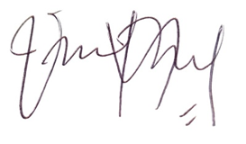

Vritta Amroini Wahyudi

